**ENGINEERING JOURNAL TEMPLATE**

# Date

**18th-22 Nov**

# Tasks

* Progress made on app
* 4 working activites , pictures below

# Reflection

* Feel I have spent more time than I should have on learning basics off app development but should hopefully be an advantage in the long run

# Issues:

*Hardware:*

1. Working on app.

*Software:*

* I want to include a needle type widget but libraries are not being added in the dependences file on studio
* Aim would be something like this 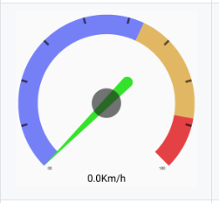

# Solutions

*Software:*

First page asks for users name and diameter of the wheel

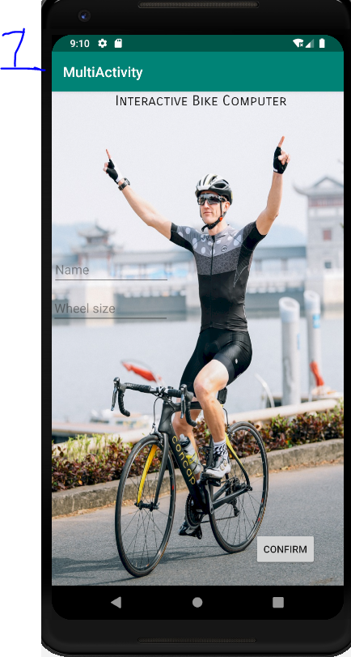

Second activity lets user know name and size of the wheel

Then gives the user the option to view the graph, realtime speed and view maps

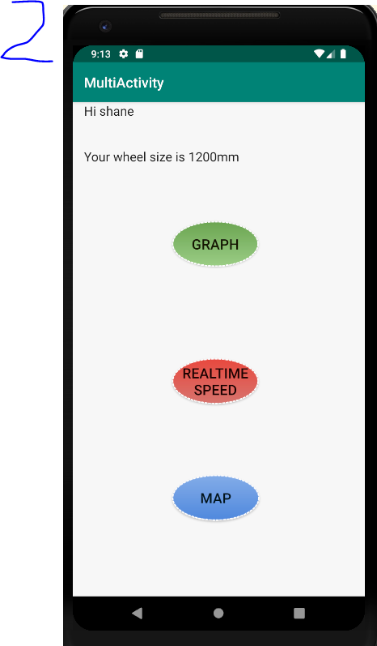

**Graph** – I want it to display live feed from the raspberry pi/hall effect sensor the speed of the wheel

**Realtime** **speed** – I want to display the speed of the wheel in needle format like example above

**MAP -** I then just want to display google maps